Dataset
Online news can be collected from different sources, such as news agency homepages, search engines, and social media websites.
We will have two parts to the data gaining process, ‘’fake news’’ and ‘’real news’’. Having this fake news was easy as Kaggle released a fake news dataset consisting 10 articles that about corona virus. It will be easy to get the real news for the fake news dataset. The real news can be found on reliable sources. The real news was generated from https://sacoronavirus.co.za/
We will use Fact-checking and Text-classification algorithms for our output.
We will have our algorithm choice, given the dataset, after selecting the features, we should choose the suitable algorithm to extract these features from the dataset. Specified the dataset, algorithm, and parameters, training uses computational resources in order to build a model of the data in order to predict the outputs on new data. When we want to solve a problem using machine learning. A dataset with several explanations is provided for the classifier to help it finding the category of a new given observation.
2.5
Algorithm 1: Analyse Web link
input: Web link to a news article.
output: (1) Domain name.
(2) Title: Real/fake.
(3) Content: fake/real.
Step 1. Verify if the introduced link is trusted or not
Step 2. If the introduced link is classified as trusted output:
(1) Domain name.
(3) The title of the article.
(4) The content of the article.
Else, print not trusted
Possible error conditions –
If web link is invalid a banner message will be populated stating that the link is invalid or does not exist. We will use error handling.
Algorithm 2: Analyse Title of the article
Input: Title of the article
Output: fake/real
Step 1. Get the title of the article from the datasets
Step 2. Print the title
Possible error conditions –
If Title is invalid a banner message will be populated stating that the link is invalid or does not exist. We will use error handling.

Algorithm 3: Analyse the content
Input content of the article.
Output: Real/fake
Step 1. Read the dataset with fake and real news and divided it into train and test sets.
Step 2. Build the text representation model
Step 3. Fit the train data to machine learning classifiers
Step 4. Predict the label (fake/real) of the article content using the machine learning classifiers
Step 5. Use the test data to calculate the accuracy score for the machine learning classifiers
Possible error conditions –
If content is invalid a banner message will be populated stating that the link is invalid or does not exist. We will use error handling
Machine learning (ML) - to solve the problem of constructing computer programs that improve by experience. We used machine learning models to verify the article content and title. Using machine learning, we will be able to: check if the title is fake or real; decide if the article content is fake or real.
features to be tested specified?
1) domain name of the website: we will test the domain name if it’s credible or not. The test will fail if the domain link is invalid
2) for title: if the title is real or fake. We will test the title of the article. The pass will fail if the title can’t be found.
3) for content: if the content is real or fake.
We will test if the application is compatible with every device. We will also test performance of the application and functionalities. We will perform a unit test because we will be testing individual functions or methods with objects to access the functionalities.
entrance and exit criteria
We take a dataset as input; the output of the algorithm will depend on the input dataset. If the input is fake/real news dataset, then the output displays if the article is fake/real. The entrance criteria will be the dataset, if the dataset is inputted the test pass else fail. The exit criteria will include validated tests cases, test data and pass/fail criteria. The exit criteria will populate a banner message conforming that if a user want to exit the application.

Dataset

Fact-checking – Web link, Title, and Content
Machine Learning

processing
Text Classification – This classify that either real or fake

Output

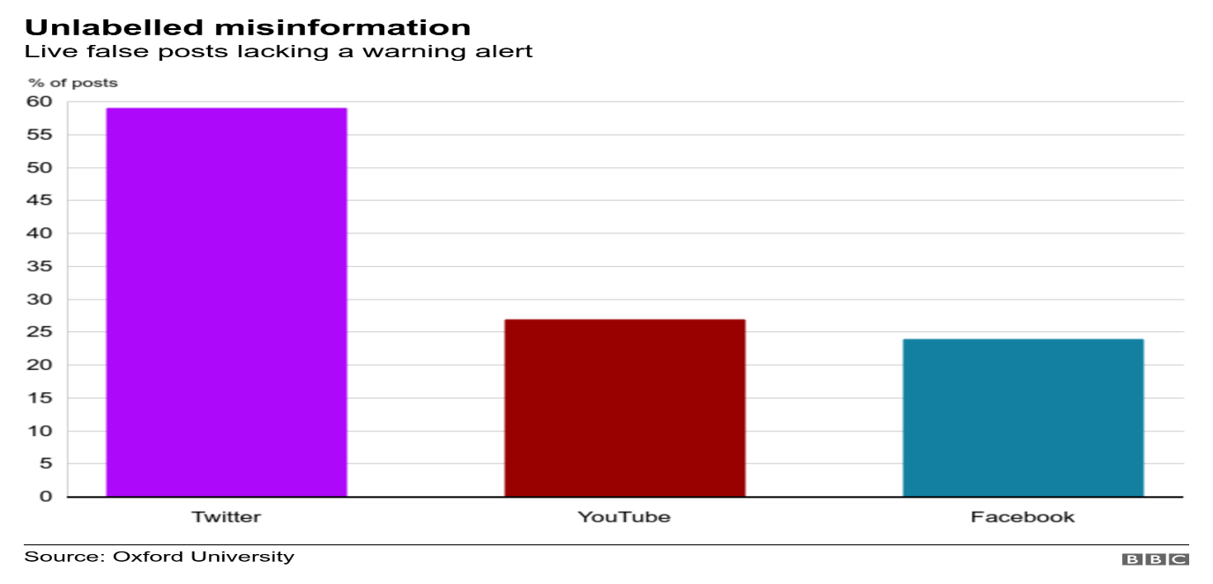
The graph above shows that how fake news about Corona virus spread through social networks.

